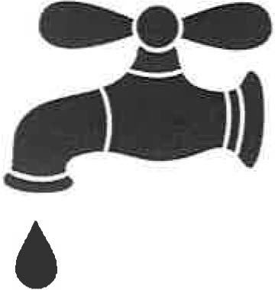
Chalk Bluff Water Supply, Corp.
6511Gholson Rd Waco, Texas 76705
Phone: (254) 799-1268
Fax: (254) 799-6191
Website: ChalkBluffWaterSupply.com Pay by Phone: 855-567-1976

Please complete the Application for Hydraulic Investigation and return to our office along with a map
marked where you would like the meter or meters.

Applications and map along with payment can be mailed to Chalk Bluff Water Supply, 6511 Gholson Rd, Waco TX 76705.

Or Applications and map can be faxed to Chalk Bluff Water Supply at 254-799-6191 or emailed to ChalkBluffWater@hot.rr.com. If Application is faxed or emailed please make your payment by credit card on our toll-free number, 1-855-567-1976 to account 1188.

Be sure to include a good telephone number and the address of the new meter.

1 Meter | $100.00
2 Meters | $200.00
3 Meters | $300.00
4 Meters | $325.00
5 Meters | $350.00
6 Meters | $375.00
7 Meters | $400.00
8 Meters | $425.00
9 Meters | $450.00
10 Meters $475.00

Please contact our office with any questions you may have.

Meter cost $3,522.00 (plus $100.00 hydraulic investigation fee) Approved meters will be valid for 90 days from the approval date.
Meters not installed within 90 days will require a New Hydraulic Investigation.

ChalkBluffWater@hot.rr.com

CHALK BLUFF WATER SUPPLY CORPORATION
APPLICATION FOR HYDRAULIC INVESTIGATION OR DESIGN TO SERVE ADDITIONAL METER OR METERS

Application made this day of 20 for water service with Chalk Bluff WSC by:
Name: _____________________________________
Address: ___________________________________
City & State: ________________________________
Telephone: _________________________________
Email: ______________________________________
Hereinafter called "Applicant". Applicant agrees to pay $100.00 in advance. which is non-refundable for the purpose of engineering. paperwork. etc. Any added cost will be at the applicant's expense. This is NOT a service agreement. only an application for service study. Charge is $100.00 minimum per meter up to $300.00 for three meters.
$25.00 per meter is charged for every meter over three meters. Additional charges may apply if a Cost Estimate of service for improvements are needed.
Address for New Meter: ___________________________________
A time of three weeks should be allowed for engineering work ups and mailings. The water system's Engineer will report his finding directly to the Board of Directors who will in turn contact the applicant.

Approved meters will be valid for 90 days from the approval date. Meters not installed within 90 days will require another Hydraulic Investigation.
Signature: ________________ Amount Paid:
CHALK BLUFF WSC Use only - Please mark on a map the proposed applicant's meter location and attach this to the request prior to forwarding to the Engineer.

Engineer's Report

ChalkBluffWaterSupply.com / ChalkBluffWater@Hot.rr.com 6511 Gholson Rd. - Waco TX 76705
254-799-1268 / Fax 254-799-6191
Payments by phone: 1-855-1976

